Carvalho_Julian_Asg2_Part1

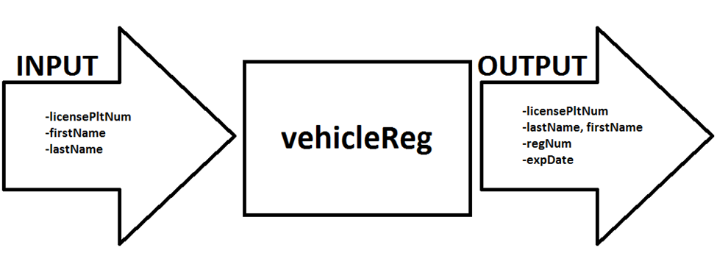

* vehicleReg
* This main method generates a registration number and an expiration date while reiterating the license plate number and the owner’s name with the last name before the first name; it calls upon other methods to do so
* Inputs:
  + Vehicle owner’s name
  + License plate number
* Outputs:
  + Vehicle owner’s name, last name then first name
  + License plate number
  + Registration number
  + Expiration date

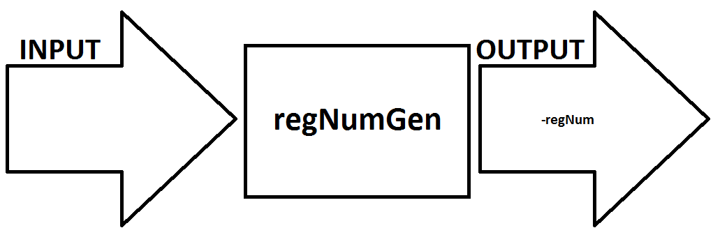

* regNumGen
* This method generates a registration number, this method can be called upon and can call upon others except for the main
* Input: none
* Output:
  + Registration number

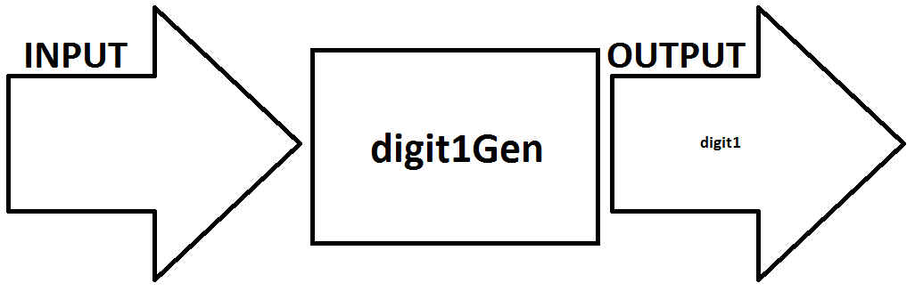

* digit1Gen
* This method generates a random number between 2-9 for the first digit of the regNumGen method, this method can be called by other methods
* Input:
  + None
* Output:
  + First digit of the registration number

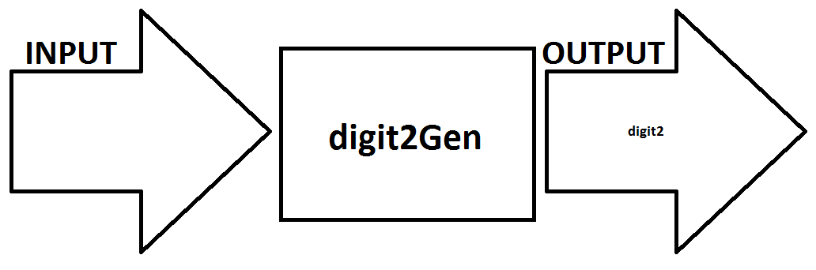

* digit2Gen
* This method generates a random number between 0-9 for the second digit of the regNumGen method, this method can be called by other methods
* Input:
  + None
* Output:
  + Second digit of the registration number

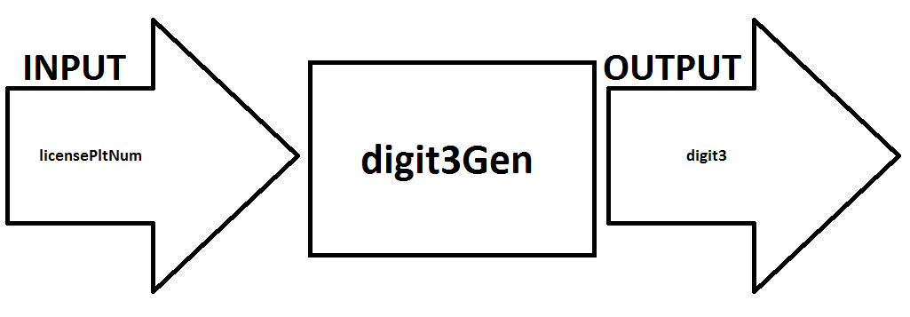

* digit3Gen
* this method calculates a number based on the license plate number entered , can be called upon by other methods
* Input:
  + License Plate Number
* Output:
  + Third digit of the registration number

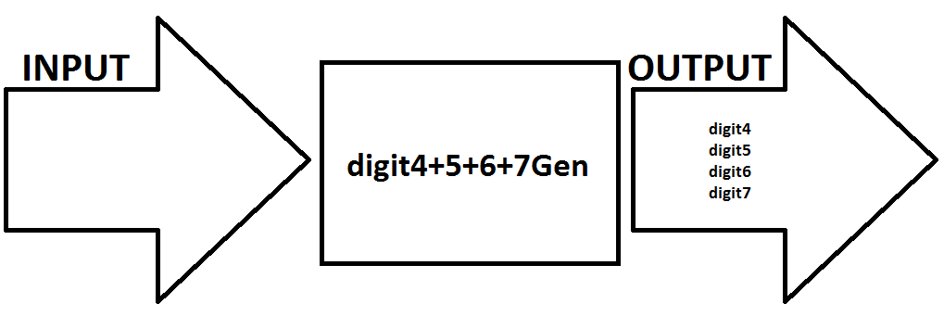

* digit4+5+6+7Gen
* This method generates a random number between 0-9999 for the fourth through seventh digits of the regNumGen method, this method can be called by other methods
* Input:
  + None
* Output:
  + Fourth, fifth, sixth, and seventh digit of the registration number

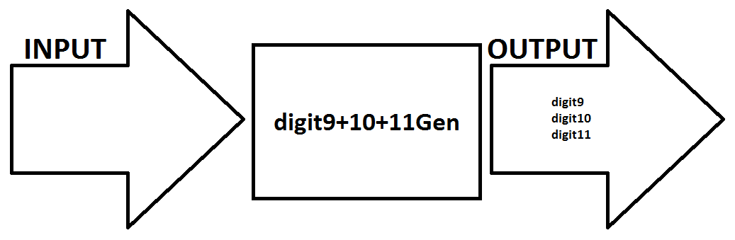

* digit9+10+11Gen
* This method generates a random number between 0-999 for the ninth, tenth, and eleventh digit of the regNumGen method, this method can be called by other methods
* Input:
  + None
* Output:
  + Ninth, tenth, and eleventh digits of the registration number

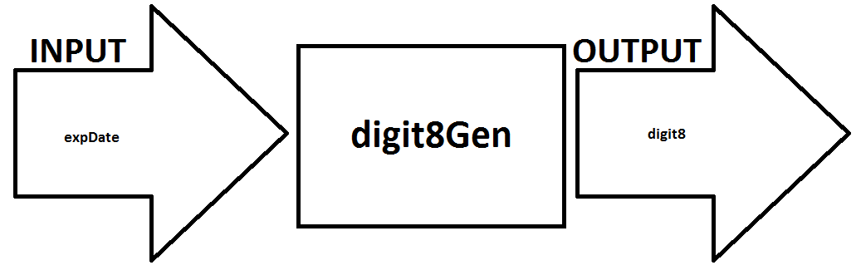

* digit8Gen
* this method calculates a number based on the expiration date entered , can be called upon by other methods
* Input:
  + Expiration date
* Output:
  + Eighth digit of the registration number

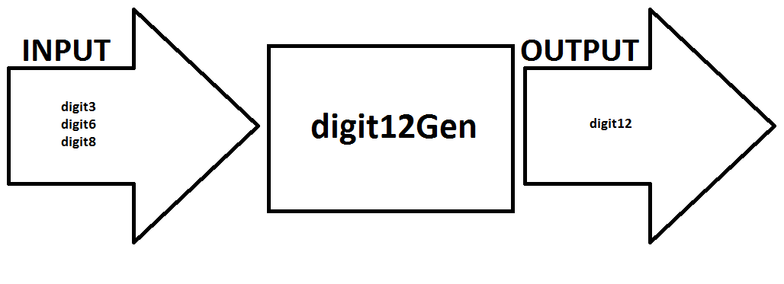

* digit12Gen
* this method calculates a number based on the other digits entered , can be called upon by other methods
* Input:
  + digit3, digit6, digit8
* Output:
  + Twelfth digit of the registration number

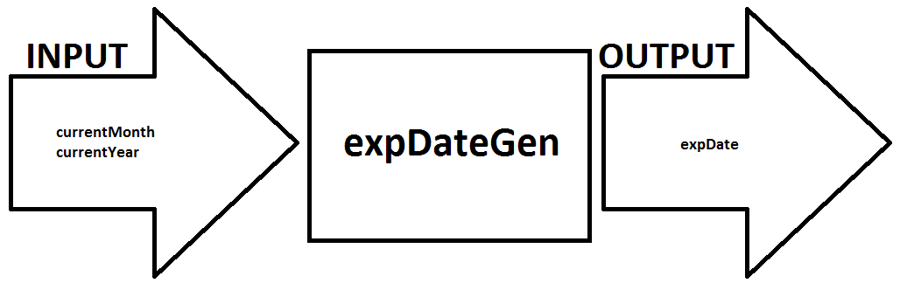

* expDateGen
* This method generates an expiry date based on the input given, can be called upon by other methods
* Input:
  + Today’s month and year
* Output:
  + Expiration date